3. Feedback control’s quality and stability
3.1 Closed loop control

Feedback occurs when the control action depends upon the measured state of the process or machine being controlled. The feedback strategy is error driven in that the control effort is a function of the difference between the required value and actual value of the controlled variable.
The elements, signals and variables of the closed loop control system:
Process field

r
u_{M}
-
d
y
e
Source
u
G_{C}(s)
G_{A}(s)
G_{P}(s)
G_{W}(s)
G_{T}(s)
y_{M}
w
Controller

Model of the process = Plant

Figure 3.1. The closed loop system

Source provides the “r” reference signal. The error detector compares the “r” reference signal and “y_{M}” measured or feedback signal. The result of the comparison is the “e” error signal. The “e” error signal is the input of the compensator and G_{C}(s) transfer function contains the control law. The most wide-spread control strategy is the PIDT1. The compensator output is the “u” action signal. The source of reference signal, the error detector and the compensator form the controller. Other elements of the control loop belong to the process field. The model of the process is the plant. The actuator characterized by G_{A}(s), the transmitter characterized by G_{T}(s) and the plant characterized by G_{P}(s) and G_{W}(s) form the process field.
The actuator G_{A}(s) is energized by the “u” action signal and provides the “u_{M}” manipulated variable. At the process output the “y” controlled variable is output of the control. The real process is energized by the “u_{M}” manipulated variable and “w” disturbance variable provide the “y” controlled variable. The input of the transmitter is the “y” controlled variable and the output is the “y_{M}” measured signal. The “d” disturbance signal represents the effect of the “w” disturbance variable. The “e” error signal represents the difference between the required and the actual value of the controlled variable.
The control loop has two inputs the “r” reference signal and the “w” disturbance variable. Because of the system is linear you can examine their effect independently each other.
<3.1.a.>
where the transfer function of the feedback system:
<3.1.b.>
and the disturbance transfer function of the feedback system:
<3.1.c.>
Sometimes the examination of the error signal is more useful.
<3.2.a.>
where the error transfer function of the feedback system:
<3.2.b.>
and the disturbance-error transfer function of the feedback system:
<3.2.c.>
Using the Laplace final theorem the 3.2.a provides the steady-state error of the closed loop system:
<3.3.>
The all transfer function of the control loop has the same denominator. The is called open loop transfer function.
<3.4.>
The transfer function of the process field is:
<3.5.>
Generally the industrial area you can only determine the transfer function of the process field energizing the process the “u” action signal and measuring the “y_{M}” feedback signal.

3.2 Stability of feedback system
A stable system remains under control. An unstable system has little relation between the input “r” reference signal and the output “y” controlled variable.
There are some methods to determine whether a system is stable or not.
Examining the stability from the closed loop transfer function
Rule: The feedback system is stable if all the roots of the denominator of the transfer function of closed loop have negative real part.
Explanation: Generally form of the transfer function of closed loop is:
<3.6.>
Using the inverse Laplace transform:
<3.7.>
The characteristic polynomial provides the transient part of the response signal:
<3.8.>
Involving the formula 3.8, the result is given form where the λi are the same roots as the denominator of transfer function of closed loop. It is clear if the real part of these roots are negative than the transient part of the response signal goes to the zero.
Examining the stability from the open loop transfer function
Rule: The feedback system is stable if at the crossover frequency and there is gain margin the phase crossover frequency on Bode or Nyquist diagram of the open loop transfer function.
Explanation of terms:
- The ω_{C} gain-crossover frequency is that where the amplitude gain of the open loop transfer function equals 1.
- The “pm” phase margin is the difference between the φ(ω_{C}) actual phase shift at the gain-crossover frequency and the -180 degree phase shift: . The open loop transfer function has “pm” phase margin if .
- The phase-crossover frequency is that where the phase shift of the open loop transfer function equals -180 degree.
- The “gm” gain margin is the reciprocal value of the actual gain at the phase-crossover frequency. The open loop transfer function has “gm” gain margin if .
Explanation: Due to the negative feedback the sinusoidal components of the feedback signal with phase shift are added and the gain at this frequency tends to infinity if the gains of the components are higher than 1. The phase margin is required because of a part of the sinusoidal components of the feedback signal with nearly phase shift are also added increased the gain at those frequencies.
3.3 Quality feature of feedback control
The step response of the closed loop is the most relevant test of the quality features. As criteria the settling time with its tolerance band, the overshoot, the remaining steady-state error and the rise time are used to specify the most important system performance.
The step response can be monotonic or oscillatory. The monotonic step response has not overshoot thus on the Fig. 3.2 the oscillatory step response of the feedback system is shown.
y_{peak}
t
y_{D}
y_{F}
T_{a2%}
T_{s}
y_{H}
Δ
Figure 3.2. Oscillatory step response of the closed loop system

The absolute integral criterion of quality is the best, but unfortunately it needs computer. The formula is the next:
<3.9.>
Explanation of terms:
- y_{D} is the required value of the control loop response determined by the reference signal.
- y_{F} is the final value of the control loop response.
- y_{H} is the remaining steady-state error of the control loop. <3.10.>
- y_{peak} is the maximum value of the control loop response.
- Δ is the tolerance band around of the final value. The typical tolerance bands are .
- The settling time or control time depends on the tolerance band. The T_{a2%} means: After this time the response signal remain inside band of the final value.
- T_{s} is the rise time. It is usually defined as the time to rise from 10% to 90% of the final value.
3.4 Exercises with their solutions
- Determine the G_{PF}(s) process field transfer function, the G₀(s) open loop transfer function and the G_{yr}(s) closed loop transfer function of the feedback system is shown on the following figure 3.3!
-
r
y
Figure 3.3. The closed loop system for the exercises

Solution: The first we define the GC, GA, GP, GT variables of MATLAB typing the next:
GC=tf(4.8,1)
GA=tf(40,[1 40])
GP=tf(230,[1 42 420 860])
GT=tf(80,[1 80])
Secondly we define the requested transfer functions according the formulas 3.5, 3.4, and 3.1.a typing the next:
GPF=GA*GP*GT
G0=GC*GA*GP*GT
Gyr=feedback(GC*GA*GP,GT)
- Examine the stability from the closed loop transfer function!
Solution: There are some commands to determine the roots of a polynomial, but the simplest to type pole command which provides the roots of the denominator of the closed loop transfer function.
pole(Gyr)
The result is highlighted on the Command window:
-80.3130
-36.0950 + 7.3029i
-36.0950 - 7.3029i
-4.7485 + 5.9290i
-4.7485 - 5.9290i
You see all roots have a negative real part, and so the system is stable.
- Examine the stability from the open loop transfer function!
Solution: You can examine it on the Bode or on the Nyquist diagram equally. We only use the Bode diagram, and so typing:
bode(Gyr)
On the appearing Figure window you can use the right mouse click → Characteristics → All Stability Margins route to find the “pm” phase margin and the “gm” gain margin. Because there isn’t gain-crossover frequency, therefore there isn’t “pm” phase margin. At the phase-crossover frequency the “gm” gain margin is marked on the amplitude curve.
- Determine the time constants of the process field transfer function and choose the highest and the second highest for the TI and TD parameters of the PIDT1 compensator! Be the differential gain and count the T time constant of DT1!
Solution: It is known negative reciprocal value of roots of a transfer function provides the time constants of the system. It is enough to type the pole command again, because the numerator of the process field transfer function hasn’t root.
pole(GPF)
The result is highlighted on the Command window and you can count from these the time constants in seconds.
, , , ,
From these values the integral time constant , the differential time constant and .

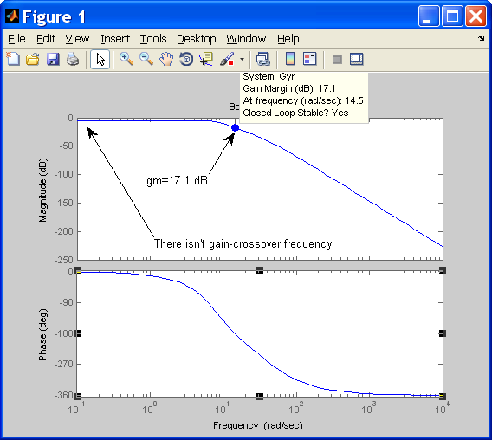

Figure 3.4. Bode diagram of the open loop transfer function

- Determine the T_{sim} simulation time and the T_{s} sample time! Download the pattern.mdl SIMULINK model and complete it with the concrete values of G_{A}(s), G_{P}(s), G_{T}(s) transfer functions!
Solution: The good choice when the settling time is a little bit less than the simulation time. The is corresponding the first approximate value for the simulation time, where are the time constants of the process field transfer function. If the sample time the system is considered to be continuous.
Be and
Note: Important that always is an integer.
Download the pattern.mdl SIMULINK model and choose the “Configuration Parameters” item from the Simulation menu the following dialog window appears:

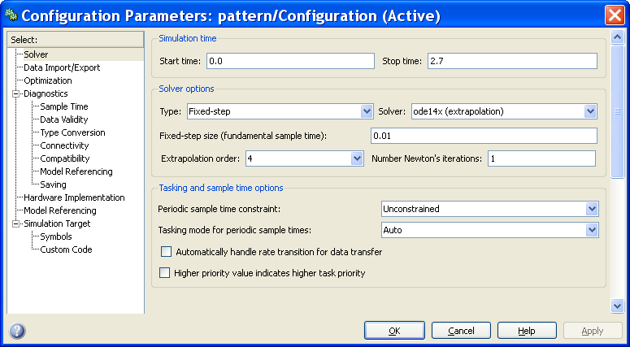

Figure 3.5. The Configuration Parameters dialog window

Fill yours dialog window similarly as shown on Figure 3.5!
After this a double click on the GA block the following (Fig. 3.6) dialog window appears and you can define the numerator and denominator of the G_{A}(s) transfer function.
Similarly can be filled the GP and GT blocks of process field, and the DT1 and I blocks of controller shown on Fig 3.7.
You aren’t ready because the K_{C} controller gain value isn’t right.

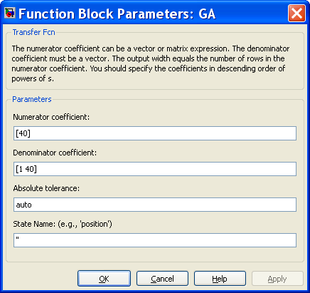

Figure 3.6. Completing of G_{A}(s) actuator transfer function

Start Simulation button

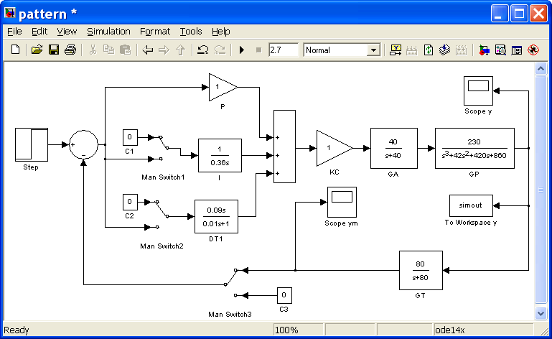

Figure 3.7. Pattern SIMULINK model
- Determine the K_{C} controller gain assuming that 60 degree phase margin of this control loop is a good choice!
Solution: The phase margin relates to the open loop transfer function. First you must define the G_{C}(s) controller transfer function assuming the unit K_{C} value.
<3.11.>
where <3.11.>
The K_{C} is in cascade in the loop and so it only offset the amplitude diagram of Bode and doesn’t change the phase diagram. Type it into MATLAB the next:
KC=1
GC1=1+tf(1,[0.36])+tf([0.09 0],[0.01 1])
G0=KC* GC1*GA*GP*GT
bode(G0)
Looking for the frequency belonged to the phase shift on the Bode phase diagram of G₀(s) at K_{C}=1! Read off the amplitude gain at this frequency!

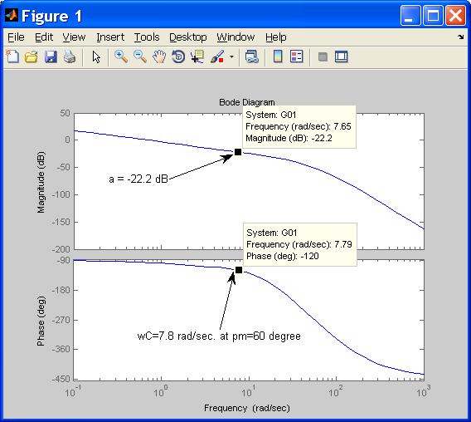

Figure 3.8. Bode diagram of G₀ at unit K_{C}
The reciprocal value the determined gain will be the K_{C} and this frequency will be the ω_{C} gain-crossover frequency.
We read off the value of amplitude gain a=-22.2 dB. The reciprocal value of this is +22.2 dB. Convert it to real number and the gain-crossover frequency is ω_{C} =7.8 rad./sec.
- Complete with the value of K_{C} of the pattern.mdl SIMULINK model! Check the response signals of the closed loop system with P, PI, PDT1 and PIDT1 compensator and choose the best quality! The first aspect to choose the best quality is the less steady-state error. The second aspect is the less overshoot. Plot the best quality response and determine the settling time with ±2% tolerance band, the overshoot and the remaining error of the system!
Solution: The Figure 3.7 shows the control loop with P controller. Closing the “Man Switch1” gives the PI configuration and the “Man Switch2” gives the PDT1 configuration. Closing the both “Man Switch” gives the PIDT1 configuration.
Trying to go trough the configuration and check the result! In this example suggested by “Scope y” the PIDT1 is the best.

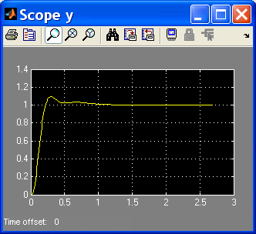

Figure 3.9. Bode diagram of G₀ at unit K_{C}

Note: Sometimes useful to click the “AutoScale” binoculars icon.
You can plot the curve above using the plot command.
There are the “tout” and the “simout” variables in the Workspace, and so you can determine the steady-state error y_{H}, the overshoot M_{P}% and the settling time T_{a2%} on the Figure window typing the next:
plot(tout,simout)
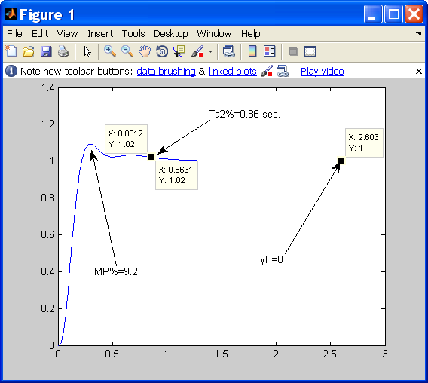

Figure 3.10. Plotting of the best choice

Note: The final value and so the tolerance band gives the 0.98 and 1.02 limits.

