6. Cascade control
The cascade control is used when the process field has at least one big time constant and there is a measurable variable between the manipulated and the controlled variables, which contain disturbance.
Due to the big time constant the process is slow that is why the time domain compensation is generally used in the cascade control.
Note: Except for the angle control with motor.
6.1 Time domain compensation
The step response of the process field is used for the time domain compensation.
Note: In the industrial area the step response is measured by the controller in manual settle the process near is the normal operating conditions. Apply a small step change to ”u” action signal and record the “y_{m}” measured signal.
The actual step response can be approximated HPT1 or IT1 transfer function depending upon the process field contains integral effect or not.
The plant without integral effect
The Figure 6.1 shows the step response of process field without integral effect.

t
y_{m}
u
Δu
Δy_{m}
T_{u}
T_{u} +T_{g}

Figure 6.1. Step response of process field without integral effect

The approximate HPT1 transfer function is:
<6.1.>
where the approximate time constant T_{g} is measured between where the tangent of the maximum slope of step response intersects the beginning and the final value of the step response. The approximate delay time T_{u} is measured from the beginning of step response to where the tangent of the maximum slope of step response intersects the beginning value of the step response. The gain is the ratio of the final amplitude of the “y_{m}” feedback signal and the “u” action signal.
Based on a number simulation experiments F. Piwinger recommendation for the right channel configuration of the PIDT1 controller:
- If, than P type controller suggested. <6.2.a.>
- If, then PI type controller suggested. <6.2.b.>
- If then PIDT1 type controller suggested. <6.2.c.>
- If, then multi loop control suggested. <6.2.d.>
- If, then I type controller suggested. <6.2.d.>
Assuming the HPT1 transfer function of the step response of the process field there are many recommendation to configure the parameters of the controller. One of them the Chien-Hrones-Reswick. The K_{P} is the gain of the process field.

Table 6.1.a. Recommendation of Chien-Hrones-Reswick for tracking

 | Aperiodically M_{p}=0% |  |  | Oscillatory M_{p} ≤ 20%
 |  | T_{I} | T_{D} |  | T_{I} | T_{D}
P | k = 0.30 | - | - | k = 0.70 | - | -
PI | k = 0.35 | 1.2 T_{g} | - | k = 0.70 | - | -
PID | k = 0.60 | T_{g} | 0.5T_{u} | k = 0.95 | 1.35T_{g} | 0.47T_{u}
Table 6.1.b. Recommendation of Chien-Hrones-Reswick for holding

 | Aperiodically M_{p}=0% |  |  | Oscillatory M_{p} ≤ 20%
 |  | T_{I} | T_{D} |  | T_{I} | T_{D}
P | k = 0.30 | - | - | k = 0.70 | - | -
PI | k = 0.60 | 4 T_{u} | - | k = 0.70 | 2.3T_{u} | -
PID | k = 0.95 | 2.4T_{u} | 0.42T_{u} | k = 1.20 | 2.0T_{u} | 0.42T_{u}

the main G_{C1}(s) and the slave G_{C2}(s) The Figure 6.1 shows the step response of process field without integral effect.

t
y_{m}
u
Δu
Out of range, limited by process
t₁
T_{g}
y_{m1}
y_{m2}
t₂
Δu

Figure 6.2. Step response of process field with integral effect

The approximate IT1 transfer function is:
<6.3.>
where the approximate time constant T_{g} is measured from the beginning of step response to where the tangent of the maximum slope of step response intersects the beginning value. The integral time constant T_{I} is measured on the straight section of the step response between two points which difference of their amplitude equals the amplitude changes of “u” action signal.
You can use P or PDT1 maybe PIDT1 controller.
Note: In the industrial area the D effect is generally not used avoiding the disturbance variables to be gained.
The Friedlich recommendation to configure the parameters of the controller is the next:

Table 6.2. Recommendation of Friedlich for tracking

 | K_{C} | T_{IC} | T_{D}
P |  | - | -
PDT1 |  | -
PIDT1

where the T_{IC} is the parameter of the controller and the T_{IP} is the measured value on the step response:
if <6.4.>
Note: Choosing the PIDT1 compensator the stability of the system strongly depends upon how many dominant time constants of the process field are which close to each other.
6.2 Structure of the cascade control
The cascade control has two compensators the main G_{C1}(s) and the slave G_{C2}(s) and two transmitters the main G_{T1}(s) and the slave G_{T2}(s) shown on Fig. 6.3.
G_{P2}(s)
G_{C1}(s)
G_{P2}(s)
G_{C2}(s)
G_{A}(s)
G_{T1}(s)
G_{W}(s)
G_{T2}(s)
y_{m1}
y
y_{m2}
Figure 6.3. The structure of the cascade control
There are three configurations of the control loop:
- The open loop when the “u” action signal is settled manual.
- Only the secondary loop is closed. The reference signal of the slave controller is settled manual and it compares the measured signal of the slave controller.
- The both the primary and the secondary loop are closed.
Configuring the parameters of controllers of cascade control
- The first step is to energize the process field with a step signal in open loop and to measure the time response “y_{m2}” at the output of the slave transmitter.
- Based on this reaction curve choose the type of the slave controller! Mostly the simple P controller enough. Avoid using the DT1 channel!
- Using the Table 6.1 or 6.2 define the parameters of the slave controller!
- Close the secondary loop and energize the process field with a step signal at the reference signal input of the slave controller! Measure the time response “y_{m1}” at the output of the main transmitter.
- Based on this reaction curve of main loop choose the type of the slave controller!
- Using the Table 6.1 or 6.2 define the parameters of the main controller!
- Close the primary loop and check the closed loop system response!
6.3 Exercises with their solutions
- Overwrite the parameters of blocks in the downloaded SIMULINK model (See: Fig. 6.5) with the parameters of the following plant model (See: Fig. 6.4)!
w
u_{M}
y_{m2}
y_{m1}
u
y
Figure 6.4. Plant’s model of exercise
Solution: For sake of simplicity on the downloaded SIMULINK model the slave controller is only a pure P (“Kc2”), the control loop is open (“StepManual” switch), the secondary loop is inactive (“SwitchOneLoop” switch). There is a Scope for the fast test, but correspond to reality we will use the measured signals (“ym1”, “ym2”) to fit the parameters of the controllers to the plant. The produced variables (“tout”, “ym1”, “ym2”) there are in the Workspace area.
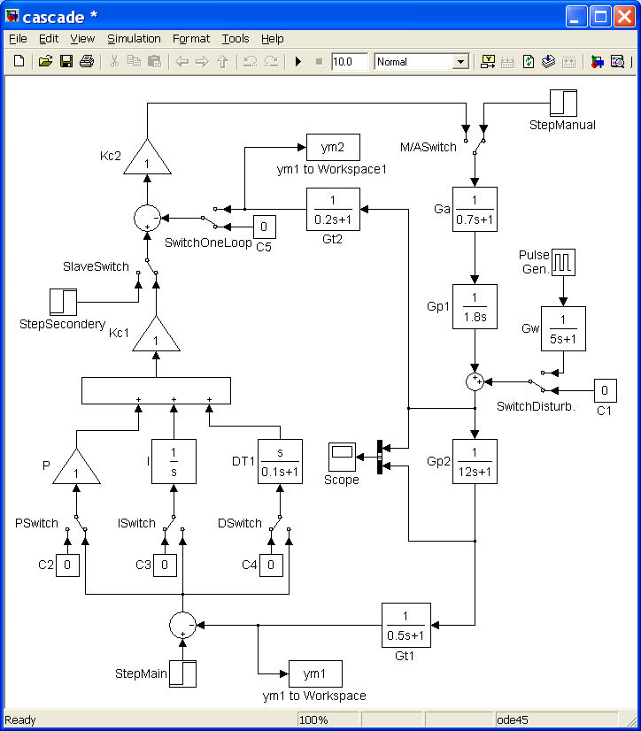

Figure 6.5. SIMULINK model
- Use the model one-loop configuration! Define the parameters of the main controller and the secondary must remain unit! Define the quality parameters of the closed, one-loop system attacked by disturbance!
Solution: First the appropriate simulation time is needed.
<6.5>
where T_{A} is the actuator, T_{IP} and T_{P} are the plant, and T_{T} is the transmitter time constants. The sample time will be 0.1 sec. Plot the measured time response of the open loop:
plot(tout,ym1)
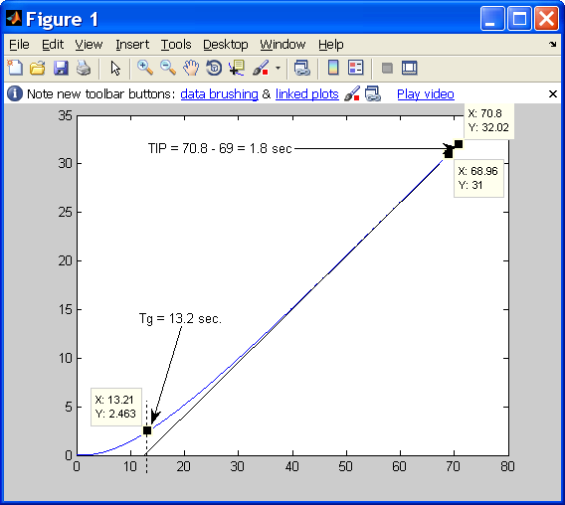

Figure 6.6. The unit step response “y_{m1}” of the plant

From the figure 6.6 reading values:
and <6.6>
We choose a PDT1 controller type, because the plant has integral effect and the time constant relative big. Due to the Table 6.2:
and <6.7>
The time constant of the differential channel of the main controller will be , supposing .
Switching the “StepManual”, “SwitchDisturb.” and “DSwitch” switch furthermore fill the counted parameters to the DT1 channel of the main controller start the simulation and plot again the result!

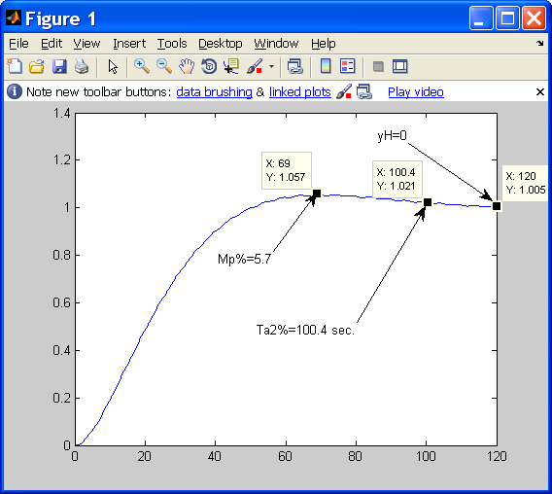

Figure 6.7. The unit step response “y_{m1}” of the closed, one-loop system

The quality parameters: The steady-state error zero and the overshoot M_{P%}=5.7 not too much, but the settling time belonging to 2% T_{a2%}=100.4 sec. is too much and the response contains the disturbance.
- Define the parameters of the secondary loop!
Solution: First open the loop and eliminate the disturbance switching the “StepManual” and “SwitchDisturb.” switches!
Second you must define again the suitable simulation time for the secondary loop!
<6.8>
where T_{A} is the actuator and T_{IP} is the plant time constants. The sample time will be 0.025 sec. Plot the measured time response of the secondary loop:
plot(tout,ym2)
From the result you can see the less simulation time T_{sim}=10 sec. is also enough (less time, more sensitive resolution).
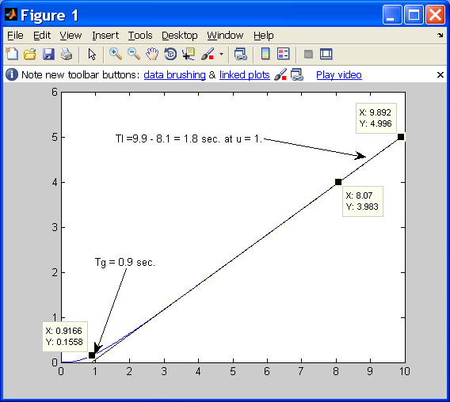

Figure 6.8. Unit step response of the secondary loop’s controlled value “y_{m2}”

From the figure 6.8 reading values:
and <6.9>
We only choose a P controller type, but it is the best choice, because the plant has integral effect and this signal will contain the disturbance.
Due to the Table 6.2:
<6.10>
- Define the parameters of the primary loop!
Solution: First close the loop switching the “StepManual” switch and energize the control loop throw the secondary controller switching the “SlaveSwitch” switch, and so the secondary loop is closed and the primary loop is open! The suitable simulation time is the same or less than it was at measuring the open loop of the whole plant. Be the T_{sim} = 60 sec. Type:
plot(tout,ym1)
First you can check that the final value of the time response equals 1, as the energizing signal is also unit the plant’s gain K_{P} = 1 (Fig. 6.9.a.).
To read the Tu and Tg use a sensitive resolution (Fig. 6.9.b.)!
From the figure 6.9.b reading values:
and <6.11>

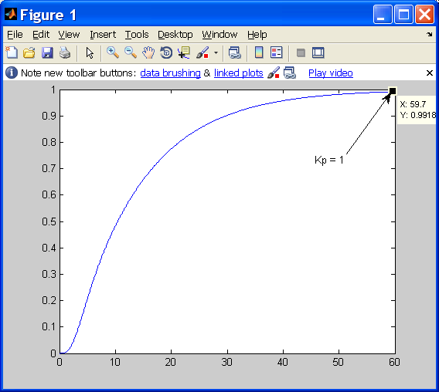 | 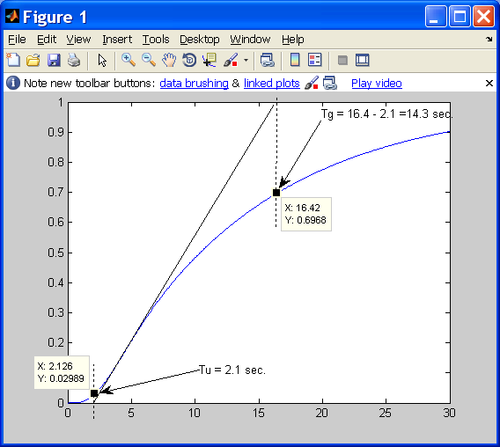
Figure 6.9.a.  Reading K_{P} parameter | Figure 6.9.b.  Reading T_{u} and T_{g} parameters

We choose a PIDT1 controller type, because the plant hasn’t got integral effect and the ratio of .
Finding an aperiodically response for tracking the reference signal use the Table 6.1.a left side.
Due to the Table 6.2:a and the reading values:
<6.12.a>
<6.12.b>
(See Fig. 6.9.b!) <6.12.c>
The time constant of the differential channel of the main controller will be , supposing .
- Use the model cascade configuration! Define the quality parameters of the closed loop system attacked by disturbance!
Solution: First overwrite the parameters of the main controller!
Second defuse “StepSecondery” (“SlaveSwitch” switch) and use “StepMain” reference signal energizing the control loop switching the “StepManual” switch to close the main loop too!
The suitable simulation time is the same, which was at measuring the open loop of the whole plant.
Add the disturbance signal to the secondary loop and start the simulation! First check on the “Scope” the responses!

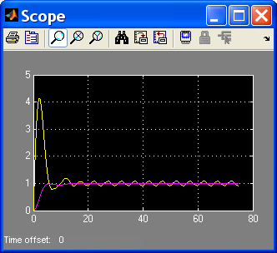

Figure 6.10. Responses of the closed loop with noise

The Fig 6.10 shows that much more less simulation time is enough. Be the simulation time T_{sim} = 25 sec. and the sample time Ts = 0.05 sec.
Defining the quality parameters of closed loop cascade control type:
plot(tout,ym1)
From the figure 6.11 reading values:
<6.13>,
there isn’t overshoot and the remaining steady-state error is also , furthermore the effect of the disturbance is less.
To demonstrate the efficiency of the cascade control we show the closed loop time response and the disturbance signal (after the G_{W}(s)) together on the Figure 6.12.
Note: On the Fig. 6.10 you can see that the actuator works hard to eliminating the effect of the disturbance.
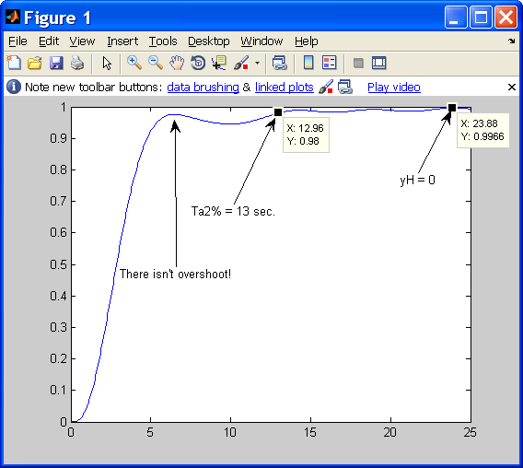

Figure 6.11. Unit step response of the closed loop cascade control with noise

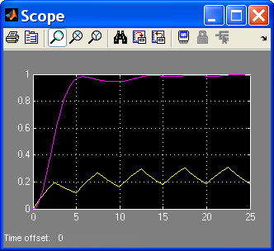

Figure 6.12. Unit step response of the closed loop cascade control with noise
and the disturbance signal

